S-100 – Part XX

Discovery Metadata for Information Exchange Catalogues

Page intentionally left blank

Contents

4a-1 Scope 1
4a-2 Conformance 1
4a-2.1 Conformance of this Profile with other Standards 1
4a-2.2 Backward compatibility 2
4a-3 Conformance to this Profile 2
4a-4 Normative references 2
4a-4.1 Profile definition 2
4a-4.2 Informative references 2
4a-5 Requirements 3
4a-5.1 Business purpose and Intended use 3
4a-5.2 Metadata for describing geographic data and other resources 4
4a-5.3 Obligations/conditions 5
4a-5.4 Minimum metadata requirements 5
4a-5.5 S-100 compliancy categories 11
4a-5.6 Recommended metadata for geographic datasets 11
4a-5.7 Variations and preferences 14
4a-5.7.1 Metadata element metadataIdentifier 14
4a-5.7.2 Metadata element parentMetadata 14
4a-5.7.3 Geographic extent of the dataset 14
4a-5.7.4 Data and Date Time information 14
4a-5.7.5 Metadata extension information 15
4a-5.8 Metadata for services 16
Appendix 4a-A Metadata Schema Class Information 19
Appendix 4a-B Data Dictionary 21
Appendix 4a-C Metadata Implementation 23
Appendix 4a-D Discovery Metadata for Information Exchange Catalogues 25
Appendix 4a-E Metadata Extensions 45

Page intentionally left blank

Scope
The S-100 Discovery Metadata for Information Exchange Catalogues profile described in this part provides a specification for describing and creating exchange catalogues that enables users to identify, discover and manage content of the S-100 exchange sets. More importantly it leverages XML to allow machine to machine discovery and exchange of information about about geographic datasets commonly produced by hydrographic organizations. Its purpose is the creation of metadata records that provide information about the identification, spatial and temporal extent, quality, application schema, spatial reference system, and distribution of digital geographic data. It is applicable to the cataloguing of datasets, clearinghouse activities, and the full description of geographic and non-geographic resources.

For information exchange, there are several categories of metadata required: metadata about the overall exchange catalogue, metadata about each of the datasets contained in the catalogue, and metadata about the support files that make up the package. If the exchange catalogue contains any Feature, Portrayal or Interoperability Catalogues there is a provision to carry additional metadata about those.

This document is intended for developers and implementers of metadata applications, and provides a basic understanding of the principles and the overall requirements for standardisation of geographic information. It should be used in conjunction with the standards listed under clause 4a-4 – Normative references.

Conformance

Conformance of this Profile with other Standards
In addition to the elements listed in ISO 19115-1, this profile also adopts all associated 19115-1 obligations and conditions, with the exception of the metadataIdentifier element which has been changed from optional to mandatory. This has been done to facilitate the implementation and management of metadata records by allowing instances of duplicate metadata records to be identified, and defining the relationship of a child metadata record with its parent metadata record. The specifics of any metadata hierarchy relationships will be detailed in the product specifications.
Taking into account the change identified above, and the requirements documented in ISO 19106:2004, this Profile meets the requirements of conformance class 1. The Profile is a community profile of ISO 19115-1 and includes an extension in the context permitted by the base standard.
This profile includes parentMetadata as a core metadata element for geographic datasets. If a dataset metadata record has a parent metadata record, then this element becomes mandatory and therefore should be considered a ‘core’ element. Guidance on the XML implementation of this profile is included at Appendix 4a-C.

Backward compatibility
According to ISO 19115-1:2014, ISO continues to make the UML models from ISO 19115:2003/Cor 1:2006 available for use. Backward compatibility is to be provided using a transformation service.

Conformance to this Profile
Any metadata claiming conformance to this Profile shall:
- Have content according to the data dictionary definitions in Annex B of ISO 19115-1, (including changes required by ISO 19115-1 Amendment 1:2018) with the exception of the metadata element metadataIdentifier which has a mandatory obligation;
- Prove conformance by validating XML document instances against the S-100 Metadata Profile schemas which are available from the IHO website at Profiles based on this Profile.
All product specific implementations of this profile shall provide an Extensible Stylesheet Language (XSL) transform file/resource that can translate the XML document instances into the S-100 Metadata Profile XML format. These resulting XML document instances shall be validated using the ISO/TS 19115-3 XSDs.

Normative references
The following referenced documents are required for the application of this document. For dated references, only the edition cited applies. For undated references, the latest edition of the referenced document (including amendments) applies.

Profile definition
The following documents were the references used to define the S-100 Metadata Profile:
ISO 19115-1:2014, Geographic information – Metadata – Part 1 - Fundamentals
ISO 19115-1/Amdt01:2018, Geographic information – Metadata – Part 1 - Fundamentals (Amendment 1)
ISO 19115-2:2009, Geographic information - Metadata - Part 2: Extensions for imagery and gridded data
ISO 19119:2016, Geographic information – Services
ISO/TS 19115-3:2016, Geographic information - Metadata - XML schema implementation for fundamental concepts

Informative references
ISO 19115:2003, Geographic information – Metadata
ISO 19115:2003/Cor.1:2006, Geographic information - Metadata (Technical Corrigendum 1)
ISO/TS 19139:2007, Geographic information - Metadata - XML schema implementation

Overview

Introduction

Overview

Figures 4a-D-1 to 4a-D-3 outline the overall concept of an S-100 exchange set for the interchange of geospatial data and its relevant metadata. Figure 4a-D-1 depicts the realization of the ISO 19115-3 classes which form the foundation of the exchange set. The overall structure of S-100 Exchange Sets is modelled in Figure 4a-D-3. More detailed information about the various classes is shown in Figure 4a-D-2 and a textual description in the tables at clause 3.
The discovery metadata classes have numerous attributes which enable important information about the datasets and accompanying support files to be examined without the need to process the data, for example decrypt, decompress, load etc. Other catalogues can be included in the Exchange Set in support of the datasets such as feature, portrayal, coordinate reference systems, codelists etc. The attribute “purpose” of the support file metadata provides a mechanism to update support files more easily.
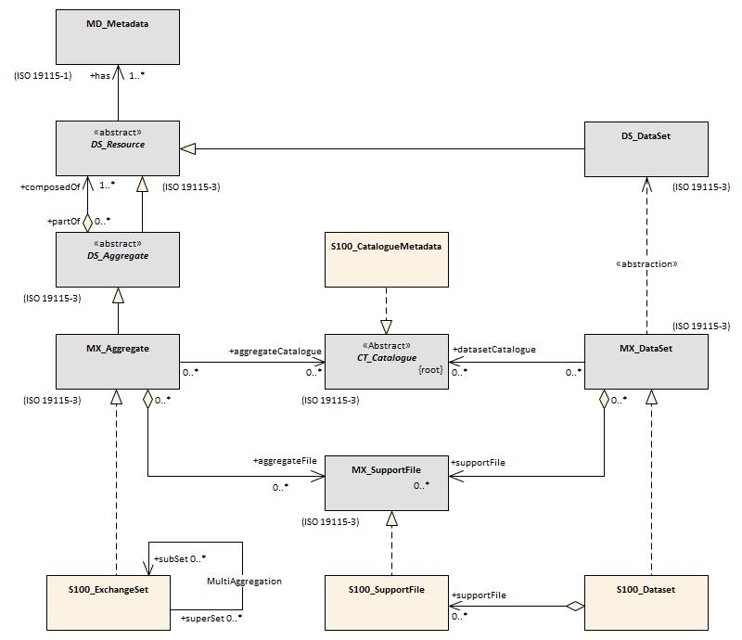
Figure 4a-D-1 Realization of the Exchange Set Classes
The S100_ExchangeCatalogue is an XML instance, which provides the information needed to exploit all the components of an Exchange Set. It consists of sections for the catalogues and datasets with subsections for support file metadata and a reference to classic ISO 19115-1 dataset metadata. The Exchange Catalogue must be named CATALOG.XML.
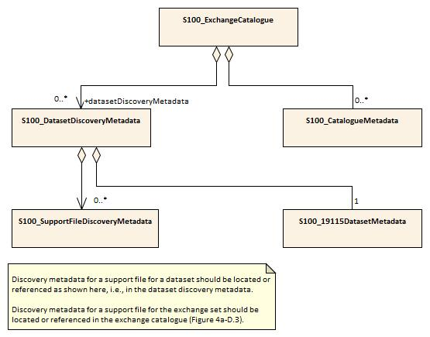
Figure 4a-D-2 – S-100 Exchange Set Catalogue
The S-100 Exchange set is a container that combines all the elements needed for the exchange of S-100 data. The exchange set may include S-100 based datasets, files, feature catalogues and portrayal catalogues as shown in figure 4a-D-3 below.
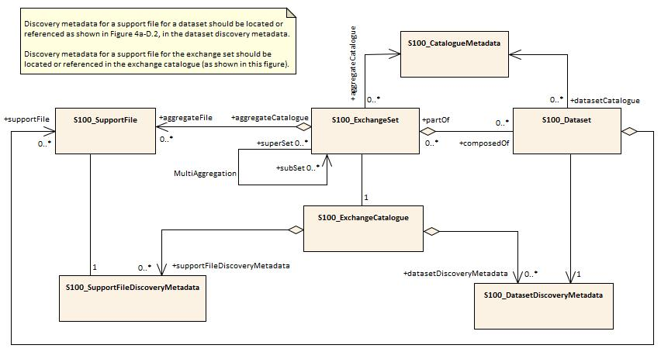

Figure 4a-D-3 – S-100 Exchange Set

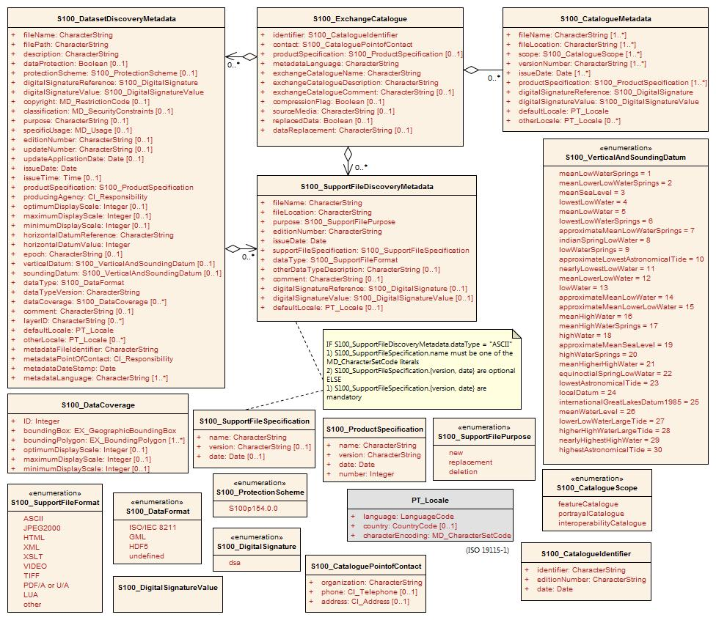
Figure 4a-D-4 – S-100 Exchange Set - class details
There are two types of Exchange Sets: simple product Exchange Sets and multiple product Exchange Sets. If only one product type (for example S-101) is included, the Exchange Set is simple type. If more than one product type (for example S-101 and S-102) is included, the Exchange Set is multiple type.

An Exchange Set can contain S-100 conformant dataset files, support files and catalogue files. It can also contain S-57 dataset files.

In any type of S-100 conformant Exchange Set all S-100 products will be available from a top root directory named S100_ROOT. This will be the only top root directory in Exchange Sets containing only S-100 products. Together with the ENC_ROOT and INFO directories (used for S-57 ENCs) the S100_ROOT directory is one of three top directories in a multiple product Exchange Set containing both S-57 and S-100 products.

Page intentionally left blank

Elements of the exchange set

S100_ExchangeSet
An S-100 Exchange Set is an aggregation of all the various elements required to support the interchange of geospatial data and metadata. The MultiAggregation association introduces the concept of using subsets which could be domain oriented, for example packaged by scale, producer, region etc.
Role Name | Name | Description | Mult | Type | Remarks
Class | S100_ExchangeSet | Aggregation of the elements comprising an exchange set for the transfer of data | - | - | -
Role | aggregateFile | Collection of support files in the exchange set | 0..* | -
Role | partOf | Collection of datasets which are part of the exchange set | 0..* | -
Role | aggregateCatalogue | Collection of catalogues | 0..* | -
Role | superSet | The master container exchange set which can contain a subSet of exchange sets | 0..*
Role | subSet | Exchange set which is part of the superSet | 0..*

S100_ExchangeCatalogue
Each exchange set has a single S100_ExchangeCatalogue which contains meta information for the data and support files in the exchange set.
Role Name | Name | Description | Mult | Type | Remarks
Class | S100_ExchangeCatalogue | An exchange catalogue contains the discovery metadata about the exchange datasets and support files | - | - | -
Attribute | identifier | Uniquely identifies this exchange catalogue | 0..1 | S100_CatalogueIdentifier
Attribute | contact | Details about the issuer of this exchange catalogue | 0..1 | S100_CataloguePointOfContact
Attribute | productSpecification | Details about the product specifications used for the datasets contained in the exchange catalogue | 0..* | S100_ProductSpecification
Attribute | metadataLanguage | Details about the Language | 0..1 | CharacterString | Default without this is English
Attribute | exchangeCatalogueDescription | Description of what the exchange catalogue contains | 0..1 | CharacterString
Attribute | exchangeCatalogueComment | Any additional Information | 0..1 | CharacterString
Attribute | compressionFlag | Is the data compressed | 0..1 | Boolean | Yes or No
Attribute | sourceMedia | Distribution media | 0..1 | CharacterString
Role | datasetDiscoveryMetadata | Exchange catalogues may include or reference discovery metadata for the datasets in the exchange set | 0..* | Aggregation S100_DatasetDiscoveryMetadata
Role | -- | Metadata for catalogue | 0..* | Aggregation S100_CatalogueMetadata | Metadata for the feature, portrayal, and interoperability catalogues, if any
Role | supportFileDiscoveryMetadata | Exchange catalogues may include or reference discovery metadata for the support files in the exchange set | 0..* | Aggregation S100_SupportFileDiscoveryMetadata

S100_CatalogueIdentifier
Role Name | Name | Description | Mult | Type | Remarks
Class | S100_CatalogueIdentifier | An exchange catalogue contains the discovery metadata about the exchange datasets and support files | - | - | -
Attribute | identifier | Uniquely identifies this exchange catalogue | 1 | CharacterString
Attribute | editionNumber | The edition number of this exchange catalogue | 1 | CharacterString
Attribute | dateTime | Creation date and time of the exchange catalogue, including time zone | 1 | Date | Format: yyyymmddThhmmssZ

S100_CataloguePointofContact
Role Name | Name | Description | Mult | Type | Remarks
Class | S100_CataloguePointOfContact | Contact details of the issuer of this exchange catalogue | - | - | -
Attribute | organization | The organization distributing this exchange catalogue | 1 | CharacterString | This could be an individual producer, value added reseller, etc.
Attribute | phone | The phone number of the organization | 0..1 | CI_Telephone
Attribute | address | The address of the organization | 0..1 | CI_Address

S100_Dataset
Role Name | Name | Description | Mult | Type | Remarks
Class | S100_Dataset |  | - | - | -
Role | composedOf | An exchange set is composed of 0 or more datasets | 0..* | -
Role | datasetCatalogue | Catalogue which is related to this dataset | 0..* | -

S100_DatasetDiscoveryMetadata
Role Name | Name | Description | Mult | Type | Remarks
Class | S100_DatasetDiscoveryMetadata | Metadata about the individual datasets in the exchange catalogue | - | - | -
Attribute | fileName | Dataset file name | 1 | CharacterString
Attribute | fileLocation | Full location from the exchange set root directory | 0..1 | CharacterString | Path relative to the root directory of the exchange set. The location of the file after the exchange set is unpacked into directory <S100_ROOT> will be <S100_ROOT>/<fileLocation>/<filename>  Without fileLocation the exchange set is unpacked into directory <S100_ROOT>/<filename>
Attribute | description | Short description giving the area or location covered by the dataset | 0..1 | CharacterString | For example, a harbour or port name, between two named locations etc.
Attribute | dataProtection | Indicates if the data is encrypted | 0..1 | Boolean | 0 indicates an unencrypted dataset  1 indicates an encrypted dataset
Attribute | protectionScheme | Specification or method used for data protection | 0..1 | S100_ProtectionScheme | For example S-63
Attribute | digitalSignatureReference | Digital Signature of the file | 1 | S100_DigitalSignature | Specifies the algorithm used to compute digitalSignatureValue
Attribute | digitalSignatureValue | Value derived from the digital signature | 1 | S100_DigitalSignatureValue | The value resulting from application of digitalSignatureReference  Implemented as the digital signature format specified in Part 15
Attribute | copyright | Indicates if the dataset is copyrighted | 0..1 | MD_LegalConstraints ->MD_RestrictionCode <copyright> (ISO 19115-1)
Attribute | classification | Indicates the security classification of the dataset | 0..1 | Class MD_SecurityConstraints>MD_ClassificationCode (codelist) | 1. unclassified  2. restricted  3. confidential  4. secret  5. top secret  6. sensitive but unclassified  7. for official use only  8. protected  9. limited distribution
Attribute | purpose | The purpose for which the dataset has been issued | 0..1 | MD_Identification>purpose  (codelist) | 1. new dataset  2. new edition  3. update  4. re-issue  5. cancellation
Attribute | specificUsage | The use for which the dataset is intended | 0..1 | MD_USAGE>specificUsage (character string)  MD_USAGE>userContactInfo (CI_Responsibility) | For example, in the case of ENCs this would be a Navigational Purpose classification
Attribute | editionNumber | The edition number of the dataset | 0..1 | CharacterString | When a data set is initially created, the edition number 1 is assigned to it. The edition number is increased by 1 at each new edition. Edition number remains the same for a re-issue.
Attribute | updateNumber | Update number assigned to the dataset and increased by one for each subsequent update | 0..1 | CharacterString | Update number 0 is assigned to a new dataset
Attribute | updateApplicationDate | This date is only used for the base cell files (that is new data set, re-issue and new edition), not update cell files. All updates dated on or before this date must have been applied by the producer | 0..1 | Date
Attribute | issueDate | Date on which the data was made available by the data producer | 0..1 | Date
Attribute | issueTime | Time of day at which the data was made available by the data producer | 0..1 | Time | The S-100 datatype Time
Attribute | productSpecification | The product specification used to create this dataset | 0..1 | S100_ProductSpecification | If not available, the default is to use file extension, for example S421 for S-421, etc.
Attribute | producingAgency | Agency responsible for producing the data | 0..1 | CI_Responsibility>CI_Organisation or  CI_Responsibility>CI_Individual | See Tables 4a-2 and 4a-3
Attribute | optimumDisplayScale | The scale with which the data is optimally displayed | 0..1 | Integer | Example: A scale of 1:25000 is encoded as 25000
Attribute | maximumDisplayScale | The maximum scale with which the data is displayed | 0..1 | Integer
Attribute | minimumDisplayScale | The minimum scale with which the data is displayed | 0..1 | Integer
Attribute | horizontalDatumReference | Reference to the register from which the horizontal datum value is taken | 0..1 | characterString | For example, EPSG
Attribute | horizontalDatumValue | Horizontal Datum of the entire dataset | 0..1 | Integer | For example, 4326
Attribute | epoch | Code denoting the epoch of the geodetic datum used by the CRS | 0..1 | CharacterString | For example, G1762 for the 2013-10-16 realization of the geodetic datum for WGS84
Attribute | verticalDatum | Vertical Datum of the entire dataset | 0..1 | S100_VerticalAndSoundingDatum
Attribute | soundingDatum | Sounding Datum of the entire dataset | 0..1 | S100_VerticalAndSoundingDatum
Attribute | dataType | The encoding format of the dataset | 1 | S100_DataFormat
Attribute | dataTypeVersion | The version number of the dataType. | 1 | CharacterString
Attribute | dataCoverage | Provides information about data coverages within the dataset | 0..* | S100_DataCoverage
Attribute | comment | Any additional information | 0..1 | CharacterString
Attribute | layerID | Identifies other layers with which this dataset is intended to be used or portrayed | 0..* | CharacterString | For example, a marine protected area dataset needs an ENC dataset to portray as intended in an ECDIS
Attribute | defaultLocale | Default language and character set used in the dataset | 0..1 | PT_Locale | In absence of defaultLocale the language is English
Attribute | otherLocale | Other languages and character sets used in the dataset | 0..* | PT_Locale
Attribute | metadataFileIdentifier | Identifier for metadata file | 0..1 | CharacterString | For example, for ISO 19115-3 metadata file
Attribute | metadataPointOfContact | Point of contact for metadata | 0..1 | CI_Responsibility>CI_Individual or  CI_Responsibility>CI_Organisation | Only if metadataPointOfContact is different to producingAgency
Attribute | metadataDateStamp | Date stamp for metadata | 0..1 | Date | May or may not be the issue date
Attribute | metadataLanguage | Language(s) in which the metadata is provided | 1..* | CharacterString
Attribute | replacedData | If a data file is cancelled is it replaced by another data file | 0..1 | Boolean
Attribute | dataReplacement | Cell name | 0..* | CharacterString | A dataset may be replaced by 1 or more datasets
Role | -- | Containment of, or reference to, discovery metadata for the support files referenced in the dataset | 0..* | Aggregation S100_SupportFileDiscoveryMetadata

S100_DataCoverage
Role Name | Name | Description | Mult | Type | Remarks
Class | S100_DataCoverage | A spatial extent where data is provided; and the display scale information for the provided data | - | - | -
Attribute | ID | Uniquely identifies the coverage | 1 | Integer | -
Attribute | boundingBox | The extent of the dataset limits | 1 | EX_GeographicBoundingBox | -
Attribute | boundingPolygon | A polygon which defines the actual data limit | 1..* | EX_BoundingPolygon | -
Attribute | optimumDisplayScale | The scale with which the data is optimally displayed | 0..1 | Integer | Example: A scale of 1:25000 is encoded as 25000
Attribute | maximumDisplayScale | The maximum scale with which the data is displayed | 0..1 | Integer
Attribute | minimumDisplayScale | The minimum scale with which the data is displayed | 0..1 | Integer

S100_DigitalSignature
Role Name | Name | Description | Code | Remarks
Enumeration | S100_DigitalSignature | Algorithm used to compute the digital signature | - | -
Value | dsa | Digital Signature Algorithm | - | FIPS 186-4 (2013)

S100_DigitalSignatureValue
Role Name | Name | Description | Mult | Type | Remarks
Class | S100_DigitalSignatureValue | Signed Public Key plus the digital signature | - | Hex | Data type for digital signature values

S100_VerticalAndSoundingDatum
Role Name | Name | Description | Code | Remarks
Enumeration | S100_VerticalAndSoundingDatum | Allowable vertical and sounding datums | - | -
Value | meanLowWaterSprings |  | 1 | (MLWS)
Value | meanLowerLowWaterSprings |  | 2 | -
Value | meanSeaLevel |  | 3 | (MSL)
Value | lowestLowWater |  | 4 | -
Value | meanLowWater |  | 5 | (MLW)
Value | lowestLowWaterSprings |  | 6 | -
Value | approximateMeanLowWaterSprings |  | 7 | -
Value | indianSpringLowWater |  | 8 | -
Value | lowWaterSprings |  | 9 | -
Value | approximateLowestAstronomicalTide |  | 10 | -
Value | nearlyLowestLowWater |  | 11 | -
Value | meanLowerLowWater |  | 12 | (MLLW)
Value | lowWater |  | 13 | (LW)
Value | approximateMeanLowWater |  | 14 | -
Value | approximateMeanLowerLowWater |  | 15 | -
Value | meanHighWater |  | 16 | (MHW)
Value | meanHighWaterSprings |  | 17 | (MHWS)
Value | highWater |  | 18 | (HW)
Value | approximateMeanSeaLevel |  | 19 | -
Value | highWaterSprings |  | 20 | -
Value | meanHigherHighWater |  | 21 | (MHHW)
Value | equinoctialSpringLowWater |  | 22 | -
Value | lowestAstronomicalTide |  | 23 | (LAT)
Value | localDatum |  | 24 | -
Value | internationalGreatLakesDatum1985 |  | 25 | -
Value | meanWaterLevel |  | 26 | -
Value | lowerLowWaterLargeTide |  | 27 | -
Value | higherHighWaterLargeTide |  | 28 | -
Value | nearlyHighestHighWater |  | 29 | -
Value | highestAstronomicalTide |  | 30 | (HAT)

Note: The numeric codes are the codes specified in the IHO GI Registry for the equivalent listed values of the IHO Hydro domain attribute Vertical datum, since the registry does not at present (20 June 2018) contain entries for exchange set metadata and dataset metadata attributes.

S100_DataFormat
Role Name | Name | Description | Code | Remarks
Enumeration | S100_DataFormat | The encoding format | - | -
Value | ISO/IEC 8211 | The ISO 8211 data format as defined in Part 10a | - | -
Value | GML | The GML data format as defined in Part 10b | - | -
Value | HDF5 | The HDF5 data format as defined in Part 10c |  | -
Value | undefined | The encoding is defined in the Product Specification | - | Use product specification specific encoding means the data product and product specification is not intended for an IHO S-100 compliant system.

S100_ProductSpecification
Role Name | Name | Description | Mult | Type | Remarks
Class | S100_ProductSpecification | The Product Specification contains the information needed to build the specified product | - | - | -
Attribute | name | The name of the product specification used to create the datasets | 0..1 | CharacterString
Attribute | version | The version number of the Product Specification | 0..1 | CharacterString
Attribute | date | The version date of the product specification | 0..1 | Date
Attribute | number | The number (registry index) used to lookup the product in the Product Specification Register of the IHO GI registry | 1 | Integer | From the Product Specification Register, in the IHO Geospatial Information Registry
Attribute | compliancyCategory | The level of compliance of the Product Specification to S-100 | 0..1 | S100_CompliancyCategory | See clause 4a-5.5

S100_CompliancyCategory
Role Name | Name | Description | Code | Remarks
Enumeration | S100_CompliancyCategory |  | - | -
Value | category1 | IHO S-100 object model compliant
Value | category2 | IHO S-100 compliant with non-standard encoding
Value | category3 | IHO S-100 compliant with standard encoding
Value | category4 | IHO S-100 and IMO harmonized display compliant

S100_ProtectionScheme
Role Name | Name | Description | Code | Remarks
Enumeration | S100_ProtectionScheme | Data protection schemes | - | -
Value | S100p15 | IHO S-100 Part 15 | - | See Part 15

S100_SupportFile
Role Name | Name | Description | Mult | Type | Remarks
Class | S100_SupportFile |  | - | - | -
Role | aggregateFile | Collection of support files | 0..* | -
Role | supportFile | File which has information about a dataset | 0..* | -

S100_SupportFileDiscoveryMetadata
Role Name | Name | Description | Mult | Type | Remarks
Class | S100_SupportFileDiscoveryMetadata | Metadata about the individual support files in the exchange catalogue | - | - | -
Attribute | fileName | Name of the support file | 1 | CharacterString
Attribute | fileLocation | Full location from the exchange set root directory | 1 | CharacterString | Path relative to the root directory of the exchange set. The location of the file after the exchange set is unpacked into directory <S100_ROOT> will be <S100_ROOT>/<fileLocation>/<filename>
Attribute | purpose | The purpose for which the support file has been issued | 1 | S100_SupportFilePurpose | For example new, re-issue, new edition, update etc.
Attribute | editionNumber | The edition number of the support file | 1 | CharacterString | When a data set is initially created, the edition number 1 is assigned to it. The edition number is increased by 1 at each new edition. Edition number remains the same for a re-issue
Attribute | issueDate | Date on which the data was made available by the data producer | 1 | Date
Attribute | supportFileSpecification | The specification used to create this file | 1 | S100_SupportFileSpecification
Attribute | dataType | The format of the support file | 1 | S100_SupportFileFormat
Attribute | otherDataTypeDescription | Support file format other than those listed | 0..1 | CharacterString
Attribute | comment | Optional comment | 0..1 | CharacterString
Attribute | digitalSignatureReference | Digital Signature of the file | 0..1 | CharacterString | Reference to the appropriate digital signature algorithm
Attribute | digitalSignatureValue | Value derived from the digital signature | 0..1 | S100_DigitalSignatureValue | The value resulting from application of digitalSignatureReference  Implemented as the digital signature format specified in Part 15
Attribute | defaultLocale | Default language and character set used in the exchange catalogue | 0..1 | PT_Locale | A support file is expected to use only one locale, because other files can be created for other languages

S100_SupportFileFormat
Role Name | Name | Description | Code | Remarks
Enumeration | S100_SupportFileFormat | The format used for the support file | - | -
Value | ASCII | UTF-8 text excluding control codes | - | Many files use UTF-8]
Value | JPEG2000 | JPEG2000 format | - | ISO 15444
Value | HTML | Hypertext Markup Language | -
Value | XML | Extensible Markup Language | -
Value | XSLT | Extensible Stylesheet Language Transformations | -
Value | VIDEO | Representation of moving images in unspecified format | -
Value | TIFF | Tagged Image File Format | -
Value | PDF/A or UA | Portable Document Format | - | ISO 19005, ISO 32000  Product Specification developers should take careful consideration in using PDF as a support file format. It is recommended that PDF never be used in products that will be used on a navigation system as it may impair night vision
Value | LUA | Lua programming language | -
Value | other | Other format | -

S100_SupportFilePurpose
Role Name | Name | Description | Code | Remarks
Enumeration | S100_SupportFilePurpose | The reason for inclusion of the support file in this exchange set | - | -
Value | new | A file which is new | - | Signifies a new file
Value | replacement | A file which replaces an existing file | - | Signifies a replacement for a file of the same name
Value | deletion | Deletes an existing file | - | Signifies deletion of a file of that name

S100_SupportFileSpecification
Role Name | Name | Description | Mult | Type | Remarks
Class | S100_SupportFileSpecification | The standard or specification to which a support file conforms | - | - | -
Attribute | name | The name of the specification used to create the support file | 1 | CharacterString
Attribute | version | The version number of the specification | 0..1 | CharacterString
Attribute | date | The version date of the specification | 0..1 | Date

S100_CatalogueMetadata
Role Name | Name | Description | Mult | Type | Remarks
Class | S100_CatalogueMetadata | Class for S-100 catalogue metadata | - | - | -
Attribute | fileName | The name for the catalogue | 1..* | CharacterString
Attribute | fileLocation | Full location from the exchange set root directory | 1..* | CharacterString | Path relative to the root directory of the exchange set. The location of the file after the exchange set is unpacked into directory <S100_ROOT> will be <S100_ROOT>/<fileLocation>/<filename>
Attribute | scope | Subject domain of the catalogue | 1..* | S100_CatalogueScope
Attribute | versionNumber | The version number of the product specification | 1..* | CharacterString
Attribute | issueDate | The version date of the product specification | 1..* | Date
Attribute | productSpecification | The product specification used to create this file | 1..* | S100_ProductSpecification
Attribute | digitalSignatureReference | Digital Signature of the file | 1 | S100_DigitalSignature | Reference to the appropriate digital signature algorithm
Attribute | digitalSignatureValue | Value derived from the digital signature | 1 | S100_DigitalSignatureValue | The value resulting from application of digitalSignatureReference  Implemented as the digital signature format specified in Part 15
Attribute | defaultLocale | Default language and character set used in the exchange catalogue | 1 | PT_Locale
Attribute | otherLocale | Other languages and character sets used in the exchange catalogue | 0..* | PT_Locale

S100_CatalogueScope
Role Name | Name | Description | Code | Remarks
Enumeration | S100_CatalogueScope | The scope of the catalogue | - | -
Value | featureCatalogue | S-100 feature catalogue
Value | portrayalCatalogue | S-100 portrayal catalogue
Value | interoperabilityCatalogue | S-100 interoperability information

S100_SV_ServiceIdentification
Role Name | Name | Description | Mult | Type | Remarks
Class | S100_SV_ServiceIdentitification | Identification of capabilities which a service provider makes available to a service user through a set of interfaces which define a behaviour | - | - | Specialization of SV_ServiceIdentification (ISO 19115-1) and thereby a specialization of MD_Identification  (The ISO attributes coupledResource and couplingType are not used.)
(Inherited properties) | (Inherited from SV_ServiceIdentification.)
Attribute | serviceType | A service type name | 1 | Class GenericName | GenericName is an abstract class for all names in a NameSpace. Each instance of a GenericName is either a LocalName or a ScopedName. A LocalName references a local object directly accessible from the NameSpace. A ScopedName is a composite of a LocalName for locating another NameSpace and a GenericName valid in the NameSpace. (ISO 19103). In short: A name that is defined in a namespace.  For S-100 services, the recommended namespace is the IALA/IMO/IHO list of Maritime Services (TBD as of May 2018)
Attribute | serviceTypeVersion | The version of the service, supports searching based on the version of serviceType | 0..* | CharacterString
Attribute | accessProperties | Information about the availability of the service, including fees, planned available date and time, ordering instructions, turnaround | 0..1 | MD_StandardOrderProcess | ISO 19115-1 B.11.5
Attribute | operatedDataset | Provides a reference to the resource on which the service operates | 0..* | CI_Citation | For any single resource referenced, only one of operatedDataset or operatesOn is allowed to be documented (not both for the same resource)
Attribute | profile | Profile to which the service adheres | 0..* | CI_Citation | profile of the standard cited in serviceStandard  The specification for the data product can be identified here
Attribute | serviceStandard | Standard to which the service adheres | 0..* | CI_Citation | For example, citation for OGC WFS, WMS, etc.
Role | operatesOn |  | 0..* | MD_DataIdentification | For any single resource referenced, only one of operatedDataset or operatesOn is allowed to be documented (not both for the same resource)
(Inherited properties) | (Inherited from MD_Identification.) (not shown)

PT_Locale
Role Name | Name | Description | Mult | Type | Remarks
Class | PT_Locale | Description of a locale | - | - | From ISO 19115-1
Attribute | language | Designation of the locale language | 1 | LanguageCode | ISO 639-2 3-letter language codes.
Attribute | country | Designation of the specific country of the locale language | 0..1 | CountryCode | ISO 3166-2 2-letter country codes
Attribute | characterEncoding | Designation of the character set to be used to encode the textual value of the locale | 1 | MD_CharacterSetCode | Use (the “Name” from the) IANA Character Set register: http://www.iana.org/assignments/character-sets. (ISO 19115-1 B.3.14)  For example, UTF-8

The class PT_Locale is defined in ISO 19115-1. LanguageCode, CountryCode, and MD_CharacterSetCode are ISO codelists which should either be defined in resource files and encoded as (string) codes, or represented by the corresponding literals from the namespaces identified in the Remarks column.

Conformance class 1 as described at Section 2 Conformance and Appendix B.3 Example of a profile with specialisations (ISO 19106:2004).
A profile of a single base standard can include a subset, which is equivalent to the entire base standard. That is, a subset can equal the whole (19106:2005, p15).
This conforms to the rules included at Annex C (ISO 19115-1:2014).

